**WAPT Week 15 OWASP Top 10 Assignment**

Contents

1. Admin Registration 2

2. Deluxe Fraud 4

3. Payback Time 6

4. Upload Size 9

5. Upload Type 11

# Admin Registration

# Deluxe Fraud

# Payback Time

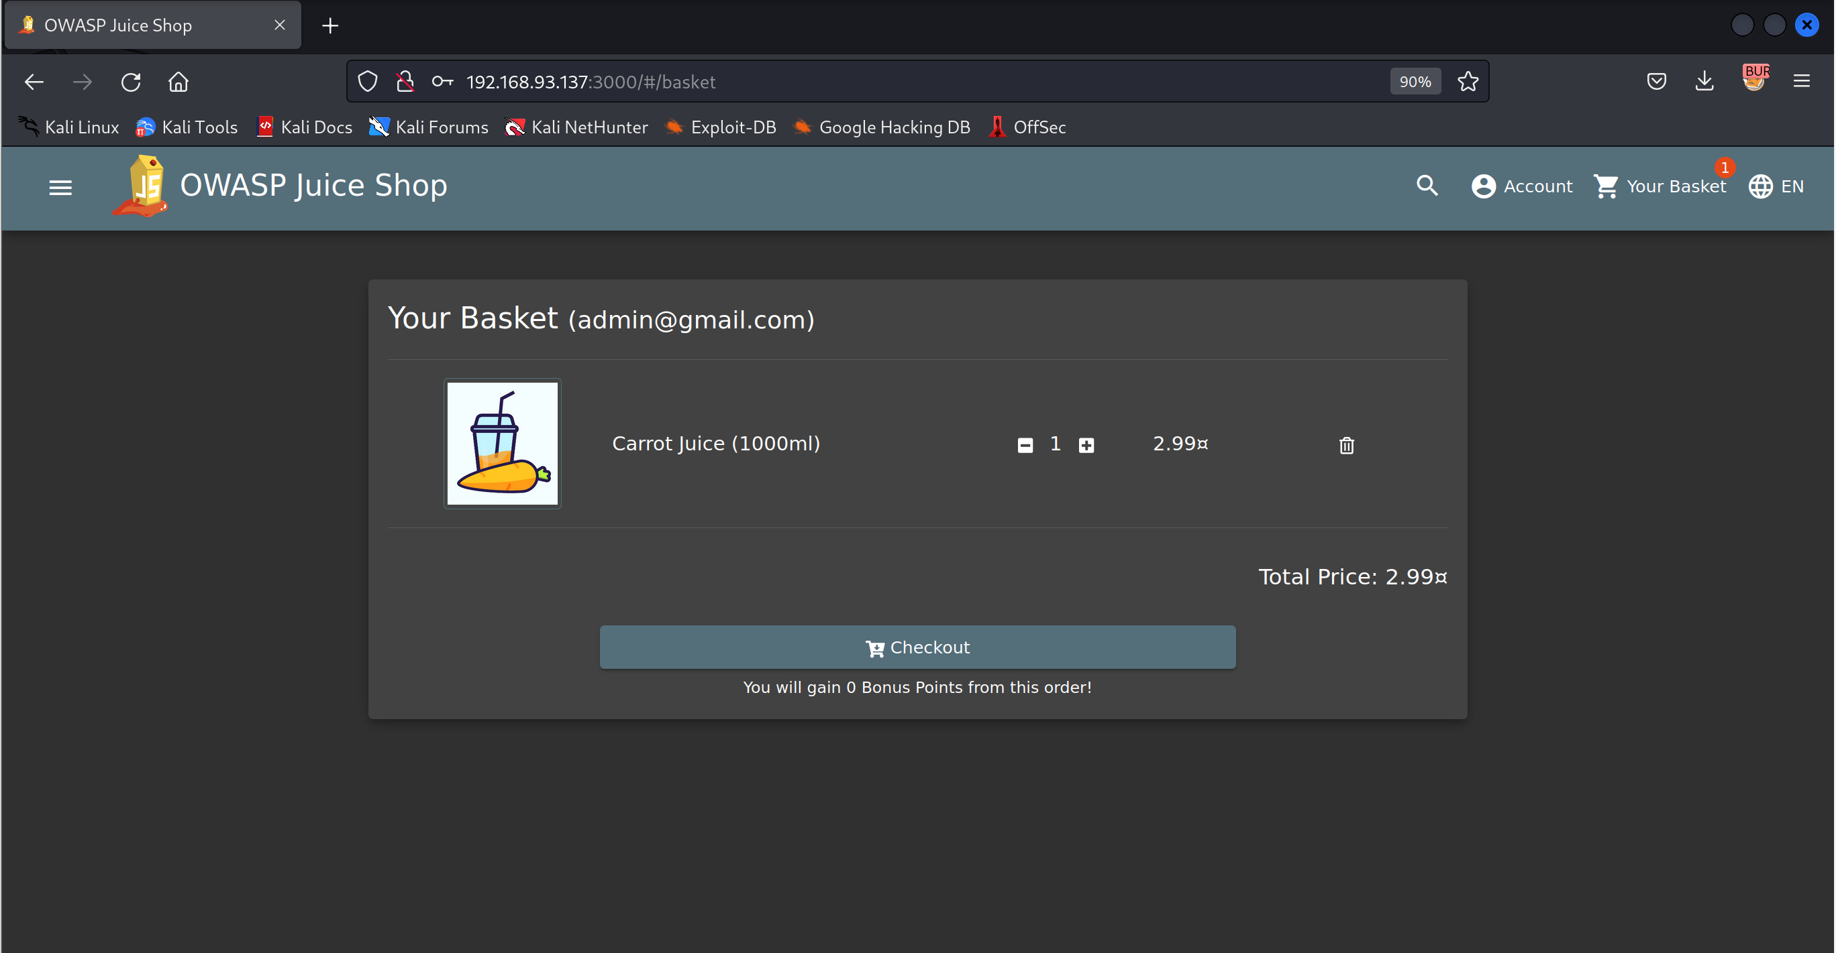

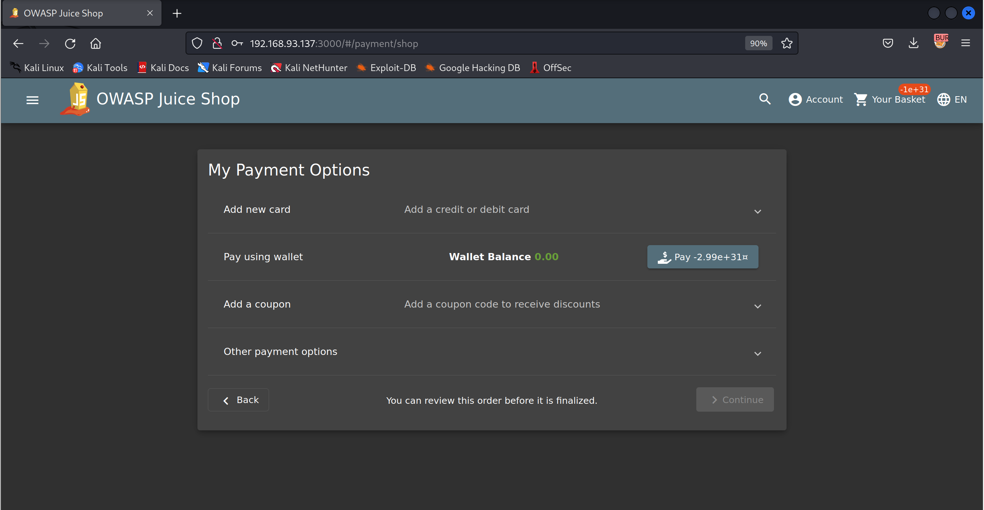

# Upload Size

# Upload Type

